Royal Thames Yacht Club Annual Regatta
for “The European International Yacht Racing Cup”
1st-3rd September 2023
Cape 31 Class
SAILING INSTRUCTIONS
Royal Thames Yacht Club
Run from Hamble Yacht Services, Port Hamble
The Organizing Authority (OA) is the RTYC Regattas Limited in conjunction with the UK Cape 31 Class Association.

The notation [DP] in a rule means that the penalty for a breach of the rule may, at the discretion of the protest committee, be less than disqualification.
- RULES
  - The event will be governed by the rules as defined in The Racing Rules of Sailing.
  - Boats are required to display bow numbers supplied and applied by the class association. This rule is not subject to protest by another boats. This changes RRS60.1.
- CHANGES TO SAILING INSTRUCTIONS
Any change to the sailing instructions will be posted before 0900 on the day it will take effect, except that any change to the schedule of races will be posted by 2000 on the day before it will take effect.
- COMMUNICATION WITH COMPETITORS
  - Notices to competitors will be posted on the official notice board located at https://cms.cape31class.com/racing/regatta5. The race committee will use the RTYC Regatta event Telegram group (See Addendum A) to alert competitors when there has been a posting.
  - The Cape 31 class race office is located at Hamble Yacht Services, Port Hamble.
  - The will be a competitor briefing at 09.00 on Friday 1st September outside the Cape 31 class office.
  - On the water, the race committee intends to monitor and communicate with competitors on VHF radio channel 06.
  - The following communications may be made by the race committee on VHF radio: location of race committee vessel, alternate preparatory signals, courses, postponement, abandonment, starting signals, recalls.
  - [DP] From the first warning signal until the end of the last race of the day, except in an emergency, a boat shall not make voice or data transmissions and shall not receive voice or data communication that is not available to all boats.
- CODE OF CONDUCT
[DP] Competitors and support persons shall comply with reasonable requests from race officials.
- SIGNALS MADE ASHORE
No signals will be displayed ashore. The race committee will use the Royal Thames Annual Regatta event Telegram group to keep competitors informed whilst ashore.

- SCHEDULE OF RACES
  - Nine races are scheduled, with a maximum of four (4) races per day may be sailed.

Race Days | Friday | Saturday | Sunday
 | 1st September | 2nd September | 3rd September
First warning signal | 10.55 | 1055 | 1025
No warning signal after |  | N/A | 1430
LW Portsmouth (UTC+1) | 0610 0.4m | 06.52 0.3m | 07.33 0.4m
HW Portsmouth (UTC+1) | 13.10 5.0m | 13.56 5.0m | 14.48 4.4m

- CLASS FLAG
The class flag will be a Cape 31 Logo on a black background.
- RACING AREA
The location of the start line will be announced via the event Telegram group by 10.00 each race day.
- COURSES
  - The diagrams in SI Addendum A show the course(s), including the approximate angles between legs, the order in which marks are to be passed, and the side on which each mark is to be rounded.
  - No later than the warning signal, the race committee signal vessel will display the course signal and the approximate compass bearing of the first leg.
  - If either gate mark 4s or 4p is missing, boats shall round the remaining gate mark to port.
- MARKS
  - Marks 1, 1a, 4s and 4p will be orange inflatable buoys.
  - Change marks (if required) will be the same colour.
  - The start mark may be a dan buoy or an anchored RIB with a staff displaying an orange flag.
  - The finish mark will be a dan buoy flying a blue flag.
- OBSTRUCTIONS
The Moving Prohibited Zone (MPZ), as detailed by the Associated British Ports of Southampton – Notice to Mariners No 08 of 2022, is designated as an obstruction. More information can be found by following this link
2022 No 08 Port of Southampton - Precautionary Area (Thorn Channel).pdf (southamptonvts.co.uk)
- THE START
  - Races will be started using RRS 26 with the warning signal made five (5) minutes before the starting signal.
  - To alert boats that a race will begin soon, the orange starting line flag will be displayed with multiple sound signals not less than five (5) minutes before a warning signal is displayed.
  - The starting line is between a staff displaying an orange flag on the committee vessel at the starboard-end and the course side of the port-end starting mark.
  - In addition to RRS 29.1, if any part of a boat’s hull is on the course side of the starting line at her starting signal and she is identified, the race committee will attempt to hail her bow or sail number on VHF radio. Failure to hail her number, failure of her to hear such a hail, or the order in which boats are hailed will not be grounds for a redress request. This changes RRS 62.1(a).
  - A boat that does not start within 4 minutes after her starting signal will be scored Did Not Start without a hearing. This changes RRS A5.1 and A5.2.
- CHANGE OF THE NEXT LET OF THE COURSE
  - To change the next leg of the course, the race committee will move the original mark or the finishing line to a new position.
  - The race committee may change a leg of the course by up to ten (10) degrees in bearing and/or 200m in length without a signal. This changes RRS 33 and Race Signals.
- THE FINISH
The finishing line is between a staff displaying a blue flag on the committee vessel at the starboard-end and the course side of the port-end finishing mark.
- PENALTY SYSTEM
  - A boat may take a One-Turn Penalty when she may have broken one or more rules of Part 2 or RRS31 while racing. However, when a boat may have broken a rule of Part 2 while in the zone around a mark other than a starting mark, her penalty shall be a Two-Turns Penalty. This changes RRS 44.1.
  - In RRS 44.2 insert after the first sentence: "However, if Mark 1a (spreader mark) is set, a boat may take a penalty for an incident in the zone around Mark 1 or on the leg between Mark 1 and Mark 1a, as soon as possible after leaving the zone around Mark 1a."
- TIME LIMIT
  - The time limit for each for race will be 90 minutes.
  - Target time of each race is 50 minutes for the first boat.
  - Finish Window: The time for boats to finish after the first boat sails the course and finishes is 15 minutes.
  - Boats failing to finish within the Finishing Window, and not subsequently retiring, penalized or given redress, will be scored Time Limit Expired (TLE) without a hearing. A boat scored TLE shall be scored points for the finishing place 2 (two) more than the points scored by the last boat that finished within the Finishing Window. This changes RRS 35, A5.1, A5.2 and A10.
- HEARING REQUESTS
  - The protest time limit is 90 minutes after the last boat finishes the last race of the day or the race committee signals no more racing today, whichever is later. The time will be posted on the online official notice board.
  - Hearing forms are available from the race office at Hamble Yacht Services.
  - Notices will be posted no later than 30 minutes after the protest time limit to inform competitors of hearings in which they are parties or named as witnesses. Hearings will be held in the Cape 31 class office.
- SCORING
  - One (1) race is required to constitute a series.
  - When fewer than five (5) races have been completed, a boat’s series score will be the total of her race scores.
  - When five (5) or more races have been completed, a boat’s series score will be the total of her race scores excluding her worst score.

- SAFETY REGULATIONS
  - [DP] A boat that retires from a race shall notify the race committee via VHF before leaving the course, or, when that is impossible, immediately after arrival ashore by contacting the race committee via the event Telegram Group.
- REPLACEMENT OF CREW OR EQUIPMENT
  - [DP] Substitution of competitors is not allowed without prior written approval of the race committee.
  - [DP] Substitution of damaged or lost equipment is not allowed unless authorized in writing by the race committee. Requests for substitution shall be made to the committee at the first reasonable opportunity, which may be after the race.
- EQUIPMENT AND MEASUREMENT CHECKS
A boat or equipment may be inspected at any time for compliance with the class rules, notice of race and sailing instructions.
- SUPPLIED BOATS
Not available

- OFFICIAL VESSELS
  - The Race Committee signal vessel will be the M/V Gemini Breeze, a white motor boat.
  - Mark laying vessels will be blue RTYC RIBs.
- SUPPORT PERSON VESSELS
  - Class rule AP1 Support vessels applies.
  - All support vessels shall carry a marine VHF radio capable of receiving and transmitting on all international channels.
  - [DP] All support vessels shall stay at least 100m outside the areas where boats are racing from the time of the first warning signal of the day until racing has concluded for the day.
- TRASH DISPOSAL
Trash may be placed on official vessels.
- BERTHING
Berthing is the responsibility of each competing boat.
- HAUL-OUT RESTRICTIONS
  - All boats shall be afloat no later than 1800 the day before the first scheduled race.
  - Boats shall not be hauled out during the regatta, except with prior written permission of the Cape 31 Executive Committee in exceptional circumstances.
- DIVING EQUIPMENT AND PLASTIC POOLS
  - Underwater breathing apparatus and plastic pools or their equivalent shall not be used around competing boats from 0900 on Friday 1st September 2023 until the end of the event.
  - No hull cleaning is permitted by a person entering the water. This rule does not prevent the removal of weed or checking for damage by entering the water.
- PRIZES
Prizes will be awarded as soon as possible after racing on Sunday 3rd September 2023 at Hamble Yacht Services to the following boats:
    - The European International Yacht Racing Cup, a perpetual trophy, will be awarded to the winner of the regatta at the annual RTYC Prize Winners’ Dinner. Invitation to follow.
    - Prizes for the top three Professionally crewed boats.
    - Corinthian Prizes will be awarded to the top 3 boat sailed with no more than one WS Category 3 crew member on board.
    - First Traveller – first boat in this regatta from a non- GBR boat, not usually based in the UK.
- RISK STATEMENT
RRS 3 states: "The responsibility for a boat’s decision to participate in a race or to continue racing is hers alone." Sailing is by its nature an unpredictable sport and therefore inherently involves an element of risk. By taking part in the event, each competitor agrees and acknowledges that:
- They are aware of the inherent element of risk involved in the sport and accept responsibility for the exposure of themselves, their crew and their boat to such inherent risk whilst taking part in the event.
- They are responsible for the safety of themselves, their crew, their boat, and their other property whether afloat or ashore.
- They accept responsibility for any injury, damage or loss to the extent caused by their own actions or omissions.
- Their boat is in good order, equipped to sail in the event and they are fit to participate.
- The provision of a race management team, patrol boats and other officials and volunteers by the event organiser does not relieve them of their own responsibilities.
- The provision of patrol boat cover is limited to such assistance, particularly in extreme weather conditions, as can be practically provided in the circumstances.
- It is their responsibility to familiarise themselves with any risks specific to this venue or this event drawn to their attention in any rules and information produced for the venue or event and to attend any safety briefing held for the event.
- INSURANCE
Each participating boat shall be insured with valid third-party liability insurance with a minimum cover of £3,000,000 per incident or the equivalent.

ADDENDUM A – Telegram Group Join Link
ADDENDUM B – Course Illustrations
ADDENDUM C – Solent Chartlet (not for navigational purposes)
# # # END # # #

ADDENDUM A – Telegram Group Join Link

Please use either: https://t.me/+EUazRoabL_Q1OGU0

Or scan the following code:

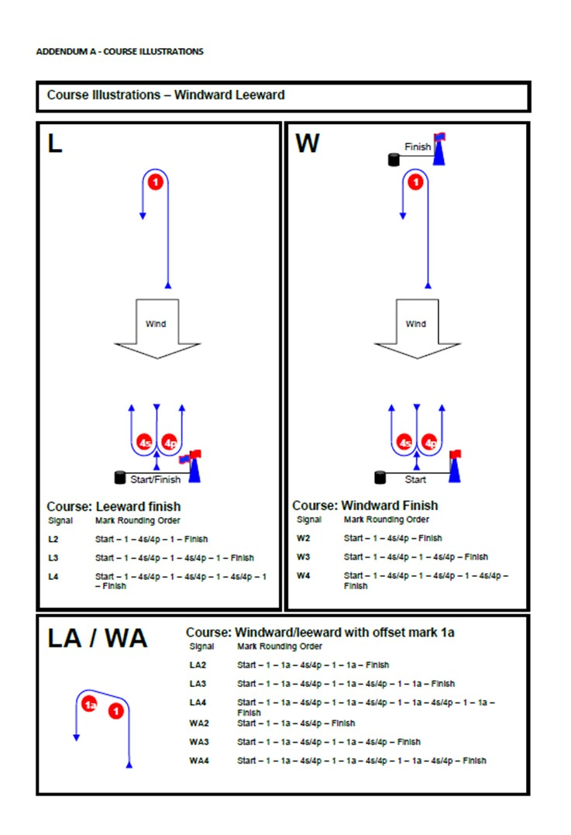
Addendum B – Course Illustrations 1

ADDENDUM C – Solent Chartlet (not for navigational purposes)

